<https://www.youtube.com/watch?v=qeH9Xv_90KM&list=PLlrATfBNZ98dudnM48yfGUldqGD0S4FFb&index=13>

Debugger

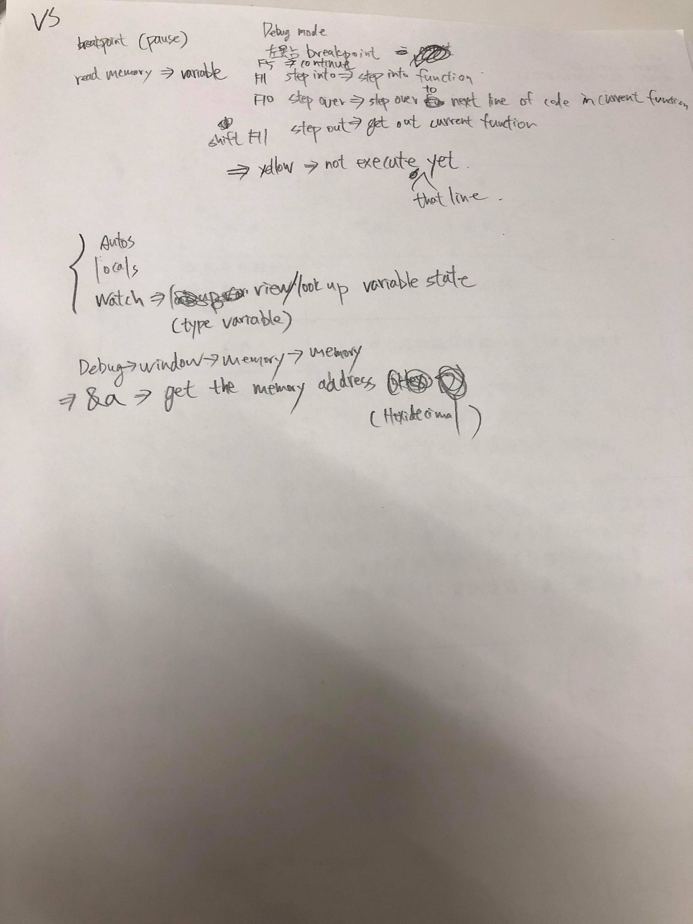

memory of a1: &a1 = 0x00EFF948

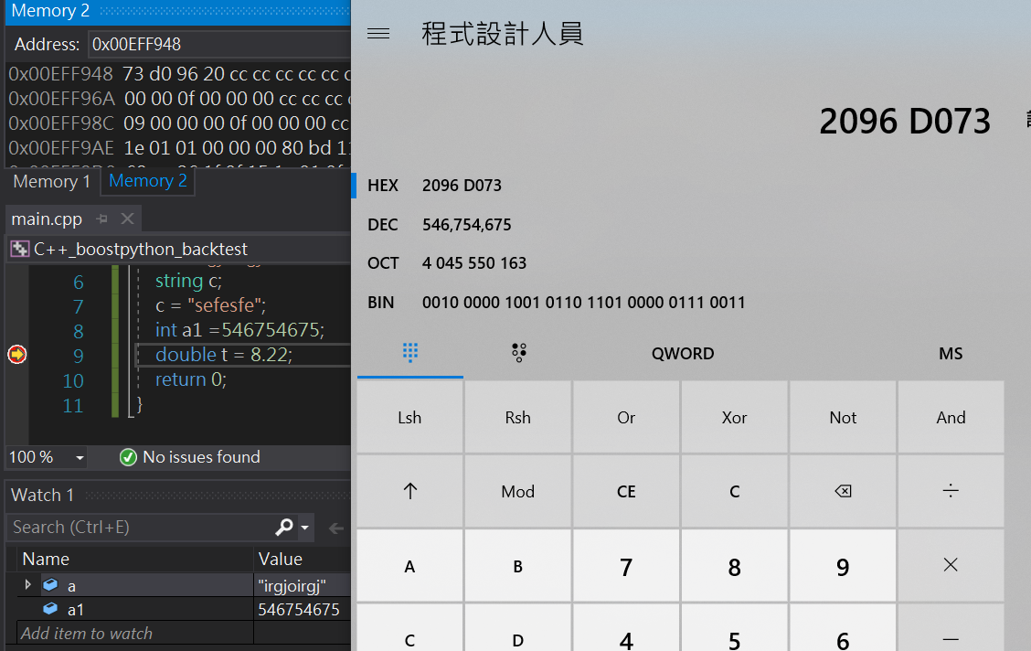

Its decimal value=546754675

Its hexadecimal(16進位) value=2096d073

Output:

$(SolutionDir)bin\$(Platform)\$(Configuration)\

Intermediate:

$(SolutionDir)bin\intermediates\$(Platform)\$(Configuration)\